**Summary**

1.Generated pickle file from the model which Sandhya had shared. This is based on DTI and Healthcare.

For that matter, we can generate pickle file from any model once the modelling code is finalised.

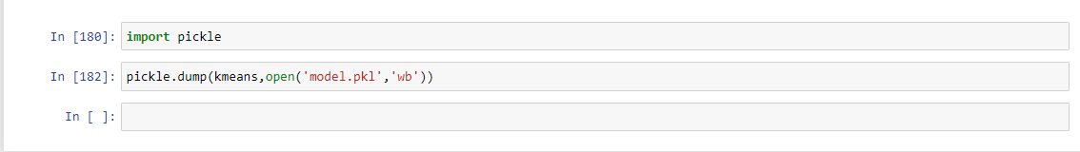

2. Created a Streamlit App to deploy the model. Here is how the file structure looks for the app.

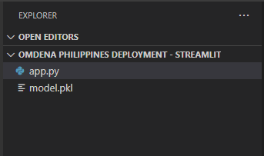

In App.py , we take our 5 indices . Then via pickle file we predict the cluster for that set of indices.

**How to run the model**

1. Open anaconda prompt and go to the folder location

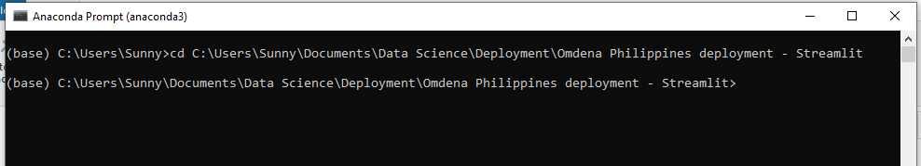

1. To run the application type: streamlit run app.ppy



1. A new window will be opened in the browser.

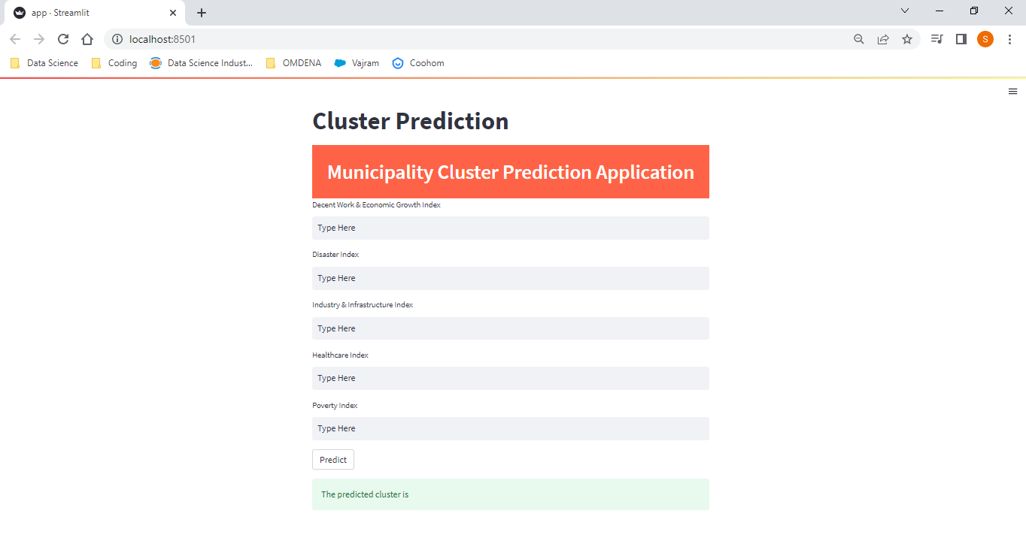

1. Input the indices and click on predict. The predicted indices will be generated.

